India’s Agricultural Crop Production Analysis(1997-2021)

**1.Introduction** :

*This report delves into the captivating realm of India's agricultural cultivation, providing a comprehensive visual exploration of key aspects and trends in the agricultural sector. Through the visual representations, readers can gain valuable insights into crop production, seasonal variations, regional distribution, and overall production trends. These visualizations enable intuitive analysis, allowing stakeholders to uncover patterns, identify areas of growth or concern, and make data-driven decisions.*

*By harnessing the power of Tableau, this report not only presents the data in a visually appealing manner but also provides an interactive experience for readers to explore the intricacies of India's agricultural cultivation. To Extract the Insights from the data and put the data in the form of visualizations, Dashboards and Story we employed Tableau tool..*

**2. PROBLEM DEFINITION AND DESIGN THINKING : 2.1 empathy map :** 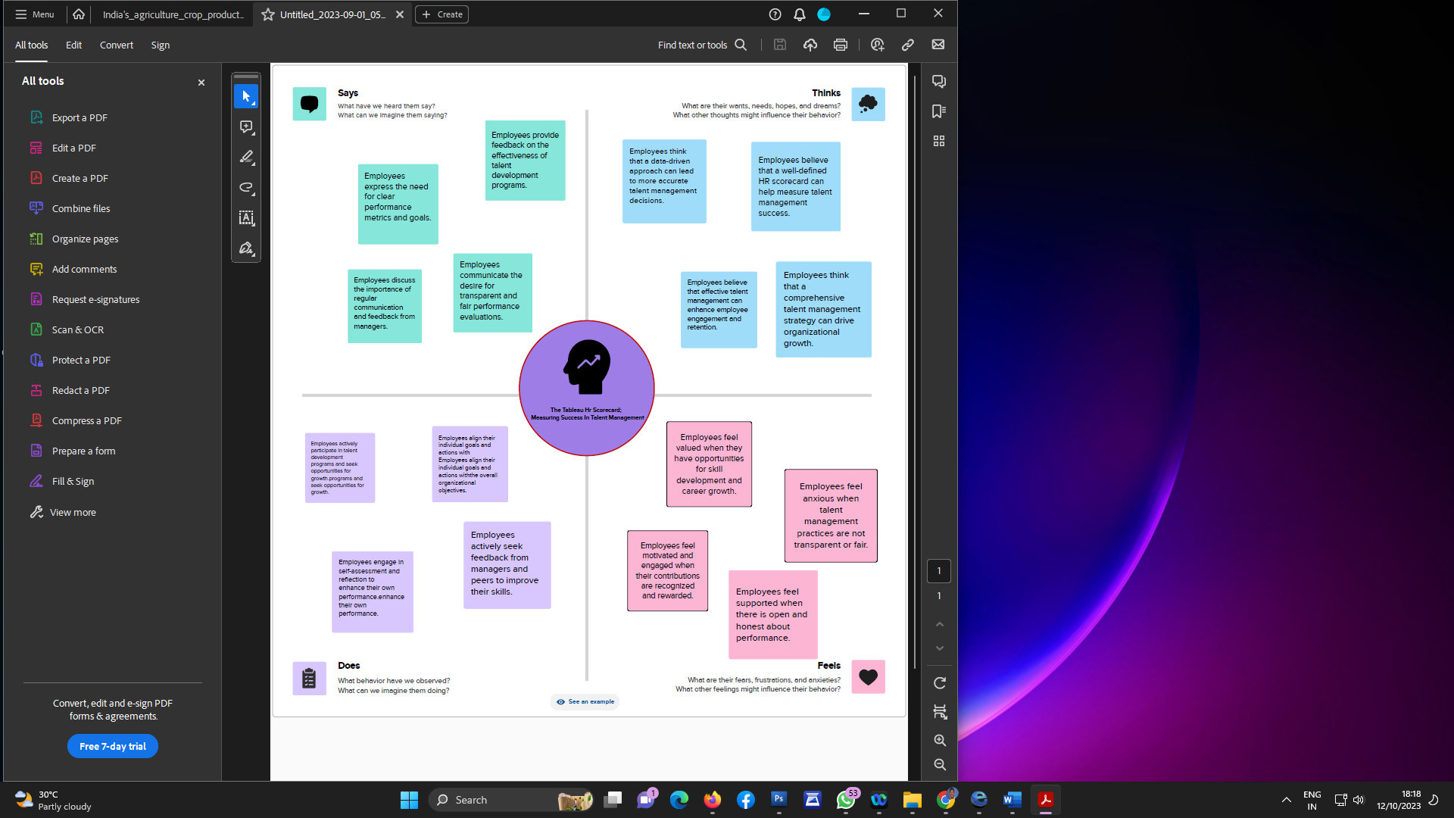

**2.2 brainstorming map:** 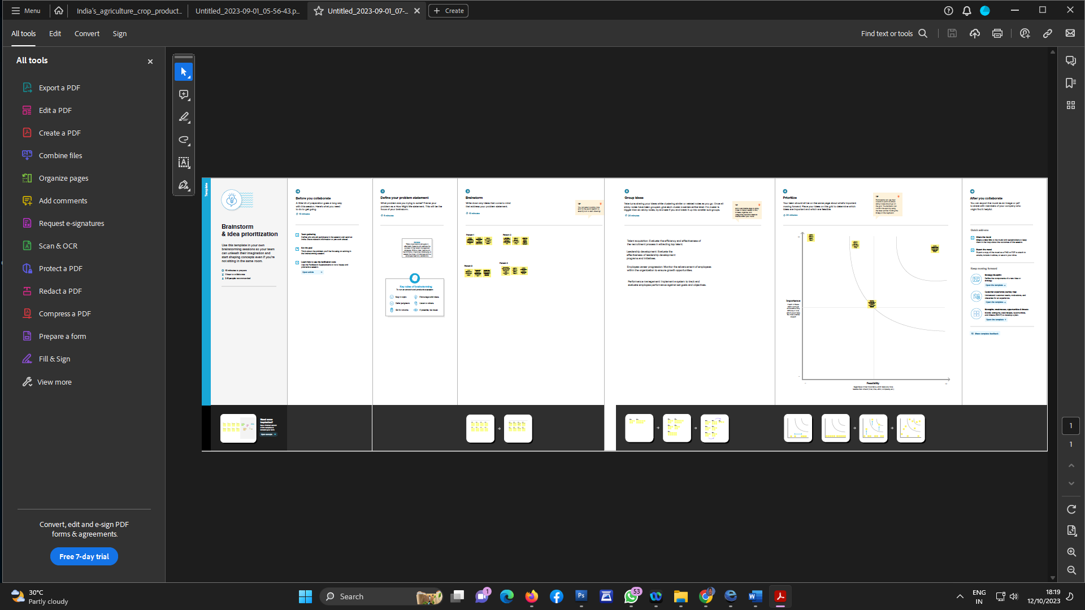

3.RESULT : 